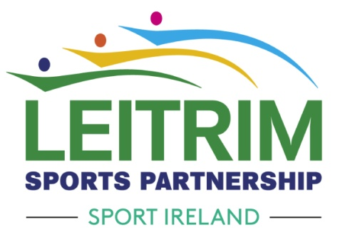

COVID 19 Club Small Grant Scheme Round II Guidelines

The COVID-19 club small grant scheme is part of a programme from the Government of Ireland, implemented through Sport Ireland and its network of Local Sports Partnerships to support the sports sector during the COVID-19 pandemic. As we are in Level Five restrictions Leitrim Sports Partnership will be facilitating a second round of this funding.This scheme is designed to support clubs, which do not have the finances to implement COVID-19 related hygiene and social distancing protocols. As the total fund available is limited, clubs which already have the finances to implement COVID-19 protocols should not apply. Clubs were successful in applying for the first round of funding can only apply up to €1000. Clubs that are applying for the first time can apply for up to €1500. New applicant s will be given priority. Clubs must ensure that, where available, they prioritise the application for funding support via their National Governing Body or relevant representative body. Funding support for the same purpose should not be sought from multiple sources.

This grant can cover costs associated with the reopening of sports clubs. The club grant scheme is designed and intended to support return to sporting activities only such as
· COVID 19 Related Costs for Hygiene Consumables (E.g. Hand sanitizer, soap, face masks, gloves etc.)
· COVID 19 Related Infrastructure Costs (E.g. Plexiglass screens, wall mounted dispensers, signage)
· COVID 19 Related venue/equipment cleaning costs
· Increased venue hire costs to comply with social distancing
· COVID 19 Related Volunteer Training Costs
· COVID 19 Related Staff Training Costs
· Additional Registration/ Event Management Costs (E.g. admin or IT costs to manage self declarations)

This funding cannot be used to support COVID-19 costs related to hospitality services such as bars or restaurants within sports facilities or commercial sector such as gyms, bootcamps etc. The COVID 19 Club Small Grants can be used to support COVID 19 related expenditure dating from 2nd May 2020 onwards (Date of publication of Government roadmap to recovery).
The scheme will be based on identified needs. Leitrim Sports Partnership and Sport Ireland and will work together to ensure that the investment is distributed fairly. Every effort will be made to ensure that the wider sports community benefits from this scheme.

There is a €1,500 limit per new applicant (club who didn’t apply or receive funding in the first round) and there is a €1000 limit for each club that received funding in the first round. On this grant scheme however applications will be means tested and only clubs with the most need will be eligible for the full amount. Clubs should not feel that they have to apply for the full amount to be considered for support.

Terms and Conditions
· Only one application can be submitted per club
· Applications must be submitted to the Leitrim Sports Partnership.
· Maximum of €1500 per new applicants // €1000 for clubs that were successful in the first round.
· The club grant scheme is intended to support return to sporting activities only expenditure dating from 2nd May 2020 onwards.
· Funding cannot be received from other organisations for items included in your application
· Clubs must have a copy of their Constitution or Club Rules;
· Affiliated member of the Public Participation Network and your NGB
· Be registered / update your club details with Leitrim Sports Partnership on a yearly basis
· Successful applicants must recognise the support of Leitrim Sports Partnership and Sport Ireland in publicity surrounding their project;
· Successful clubs must have Safeguarding done;
· The deadline for receipt of applications is 5pm Wednesday, 31st March 2021
· Late or incomplete applications will not be accepted
· Any club/organisation funded under this scheme will be asked to submit an evaluation report form to LSP and may be asked to supply documentary evidence
· If you are unsure on any of the above or have any questions, please do not hesitate to contact the office on 0719650493 or lspgrantfunding@leitrimcoco.ie

We, Leitrim Sports Partnership collect the personal data provided below for one or more specific purposes, on the basis of public authority to our statutory duties.

The purposes and reasons for processing your personal data are detailed below:
· Identifying and evaluating organisations that apply for funding
· Organisation overview and governance
· Conducting compliance checks
· Delivery of efficient services to meet organisations needs
· Recording and communicating the activities of our organisation and other organisations to stakeholders.
· Facilitating future contact with relevant stakeholders
· In order to comply with a legal obligation
· Research and development of sports participation

We do not share or disclose any of your personal information without your consent, other than for the purposes specified or where there is a legal requirement. The minimum amount of personal information is shared with Sport Ireland.
The information above should be read in conjunction with the privacy notice on our website
Paper forms are available on request. Application Forms must be posted to:

Leitrim Sports Partnership,
c/o Leitrim County Council,
Aras an Chontae,
St. Georges Terrace,
Carrick on Shannon,
Co.Leitrim
N41 K2V4

Contact Details: E: lspgrantfunding@leitrimcoco.ie P: (071) 9650498 www.leitrimsports.ie
SIGN UP TO LEITRIM SPORTS PARTNERSHIP NEWSLETTER: CLICK HERE

