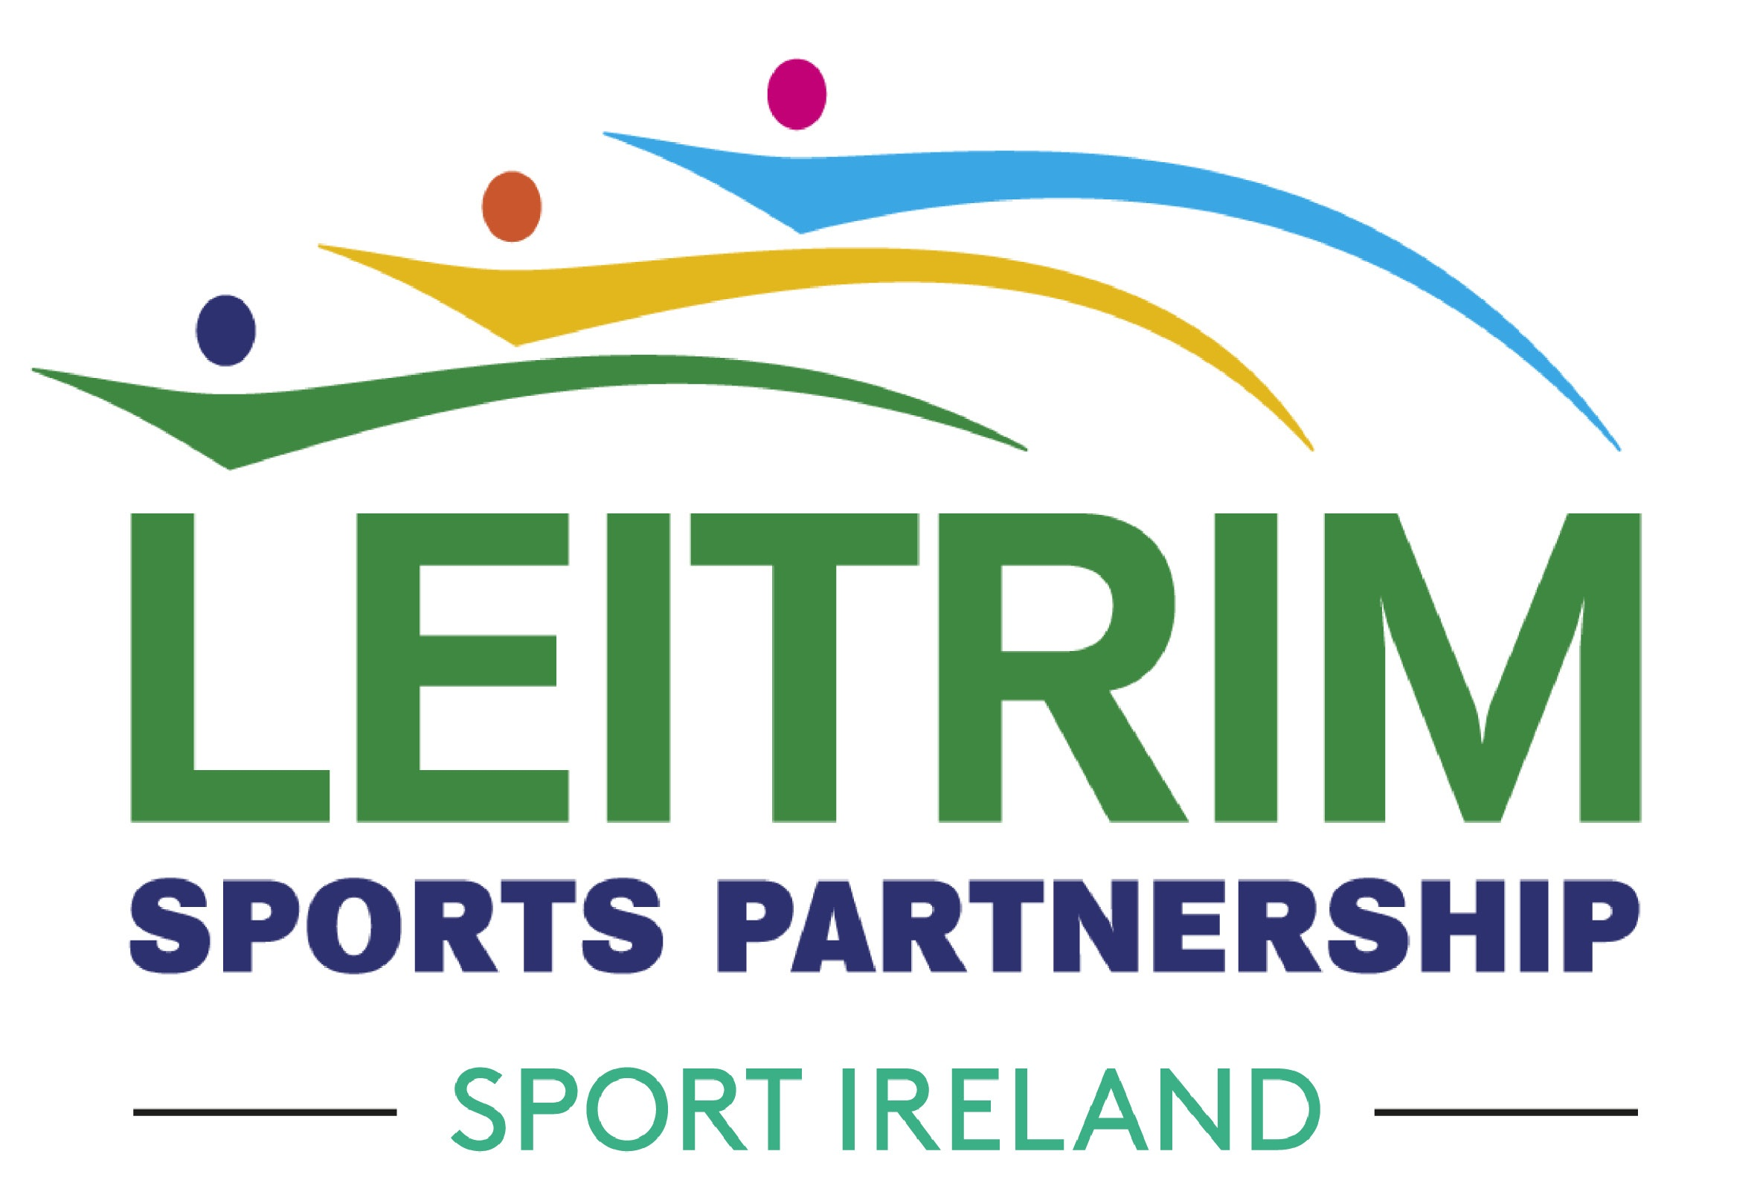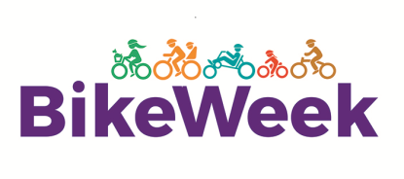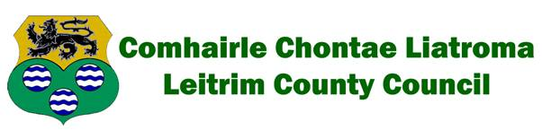

Bike Week 2023

PLEASE READ THE FOLLOWING TERMS AND CONDITIONS CAREFULLY BEFORE SUBMITTING AN APPLICATION FOR FUNDING

1. The types of groups which may apply are community groups, voluntary organisations, schools, sports clubs, active retirement groups, childcare service providers, workplaces or any group that wishes to organise a bike related event on a 'not for profit basis' during Bike Week 2023.
2. Events must be held during Bike Week 2023: Saturday 13th to Sunday 21st May 2023
3. All events must be FREE to the public/participant.
4. Bike Week logo must be used on all materials.
5. Only events/organisations based in Leitrim County are eligible to apply for funding under this scheme.
6. Event insurance: Event indemnity & insurance: The participating group(s) must indemnify Leitrim County Council in respect of any legal liability, loss, claim or proceedings arising out of or in connection with death and/or bodily injury to any persons and/or loss or damage to any property which arises directly or indirectly out of the group’s participation in Bike Week 2020. Leitrim County Council shall not be liable for any claims arising from events. The participating group(s) will be obliged to furnish evidence of their insurances in the following manner prior to the event:
Insurances to be provided on the headed paper of the Insurer or Insurance Broker and must include the following details:
- The Insurer (Not Insurance Broker)
- The Insurance Policy Number
- The period of insurance
- The Business Description on the Insurance which must cater for the group’s activities.
- The Named person /group on the Insurance Policy being the same as that applying to participate in the event.
- The Public Liability Indemnity Level must be €2.6m or higher.
- The Insurances must note an indemnity to Leitrim County Council for the purposes of the participating in Bike Week 2023.
- Failure to do so may mean that funding will not be made available.

We advise all groups to contact their insurers prior to submitting an application.
7. Where events are taking place on the public road the Gardai and Local Authority must be notified in writing of your intention to organise the event. Permission must be received in advance of the event taking place.
8. Adherence to Child Protection Guidelines: Where children or young people are participating as part of the event, organisers should familiarise themselves with Cycling Ireland's 'Code of Practise and Safeguarding Procedures for Young and Vulnerable Cyclists' which can be found at http://www.cyclingireland.ie/downloads/ci%20code%20of%20conduct.pdf. Events for children and young people should ensure a ratio of at least 1 adult to 6 children with a minimum of 2 adults per group.
9. This application process requires submission of an outline proposal (see application) to Leitrim Sports Partnership Executive Committee
10. A dedicated contact person from your organisation should be appointed. Full details for that contact person (email address and telephone number) must be submitted as part of this application process.
11. Grants will be paid to the organising group which shall be responsible for submitting a claim for payment following Bike Week and will issue as soon as possible following satisfactory receipt of the claim and the report on the event.

12. Examples of possible Bike Week events include (but are not limited to):

Bike Week Events MUST be delivered in line with one of four themes Sustainable Travel, History Cycles, Safe Cycling, Picnic Cycle;

• Guided bike tour of a town/village. These can be themed, for example, heritage, gardens, or food trips.
• Cycles from your school to a local amenity on cycle to school Tuesday or Bike to Work day (16th May) for bike based games such as treasure hunts and slow bicycle races;
• An evening cycle or club/group cycling events for public participation.
• Bike maintenance workshops
• Bike art exhibition
• Costs of complementary activities for event days, e.g. musical entertainment, face painting, novelty bike displays
• Bike school art competition, quiz or drama
• Family fun cycle/ Club Cycle/Club Time trials
• Cycling sports day
• Bike fashion show
• Picnic cycle
• Fancy dress bike parade
• Greenway Cycle
• History Tour
• Safe Cycling Promos

13. The closing date for applications is 4 p.m. Friday March 24th, 2023.
14. The dedicated contact person will be informed of the outcome by Friday April 7th, 2023.
15. Grants available may be somewhere in the range of €200 to €400 per successful group/event, depending on applications received and the nature of those applications. (Bigger grants maybe awarded for community groups organising Bike Week community festivals etc)
16. You will need to ensure that your organisation has the capacity to absorb the costs of organising this event (paying invoices to suppliers etc.) until such time that the payment of the grant issues.
17. Following Bike Week, and as a condition of payment, a brief report on the event must be submitted. The report will consist of:
• Copies of paid invoices relating to expenditure on your Bike Week event.
• A brief account of the event-one paragraph of text, testimonials from the project coordinator, participants, parents and children will suffice.
• At least two photographs (which must include a group photos) of the event-preferably received by e-mail as JPG, PDF etc.
• Copies of any media coverage that the event received.

18. The post event report will need to be furnished to the above e-mail/postal address on or before Friday 9th June
2023.
19. Grants will be paid to the organising group which shall be responsible for submitting a claim for payment following Bike Week and will issue as soon as possible following satisfactory receipt of the claim and the report on the event.

For further details and information on this application process contact sports@leitrimcoco.ie or call 071-9650498, log onto www.leitrimsports.ie

Completed applications should be e-mailed to sports@leitrimcoco.ie or, alternatively, application forms can be posted to Leitrim Sports Partnership, Aras an Chontae, Carrick on Shannon, Co Leitrim.

For further ideas on Bike Week activities log onto www.bikeweek.ie

APPLICATION FORM FOR COMMUNITY GROUPS FOR FUNDING TO ASSIST WITH THE ORGANISATION OF A CYCLING THEMED EVENT DURING BIKE WEEK: 13th – 21st May 2023

1) Organiser's Details
Organisation name Organisation contact
address
2) Contact details
Contact person’s name Landline number
Mobile number where possible

Email address
Planned Bike Week 2023 event
Outline of planned event:

(a.) Event Title:

(b.) Brief Description of Event:

(c.) Target Audience (e.g. young people, families, older age groups etc.):

(d.) Anticipated number participating:

(e.) Indicate proposed date(s) for your Bike Week 2023 Preferred Date 1:

Preferred Date 2

Area(s) of Expenditure | Estimated cost €
Total

4) Organiser's Insurance Details:
(Grantee has to Indemnify Leitrim County Council on their insurance policy and a copy of a letter to accompany their application form.)

(a.) Company:

(b.) Type of cover applicable to this event (e.g. public liability, personal accident):

(c.) Letter from insurance company submitted with this application(as per point 6 Terms and Conditions):
A letter from your organisation's insurance company indemnifying Leitrim County Council the above and giving details regarding insurance cover of the proposed event must accompany this application.

Yes No

If 'No' please give reason:

5) Indicative Funding sought:
6) Declaration by main contact person:
I hereby apply for approval for grant funding as part of the Leitrim County Council/Leitrim Sports Partnership scheme to assist Community Groups with the organisation of a cycling themed event as part of Bike Week 2023 (13th to 21st May 2023). I also declare (on behalf of the above named organisation) that I have read and understood the terms and conditions on page 1 and 2 of this application:

Signed

(Name in Capitals and Title)

Date:

