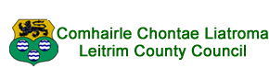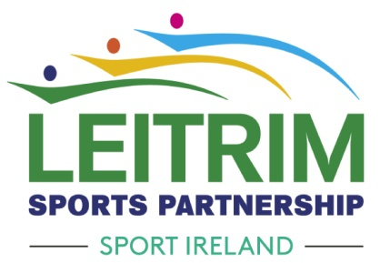
Leitrim Horse-Riding and Animal Welfare Project 2023
Horse-Riding Programme for 11–17 year olds
Horse-Riding Programme for Autists aged 7 – 11 year old
Participants
- Children aged 11-17 from traveller, disadvantaged, non-national or refugee backgrounds and children with autism aged 7-11.

Aims of the Programme
- Participants will gain horse-riding and equine husbandry skills.
- Participants will gain knowledge of animal welfare.
- Children will participate in a novel sport and gain increased self-confidence in a socially interactive environment.
- Focus on positive mental health & resilience.

Programme Outline
- Horse-riding lessons
- Horse Care and Stable Management.
- Equine Welfare.
- Equine Dentistry
- Farrier
- Pony Camp

Moorlands Equestrian Centre, Drumshanbo, Co Leitrim.

Closing date for applications Friday 5th May 2023 @ 4pm

For further information please contact Leitrim Sports Partnership 071 9650498 or sports@leitrimcoco.ie

